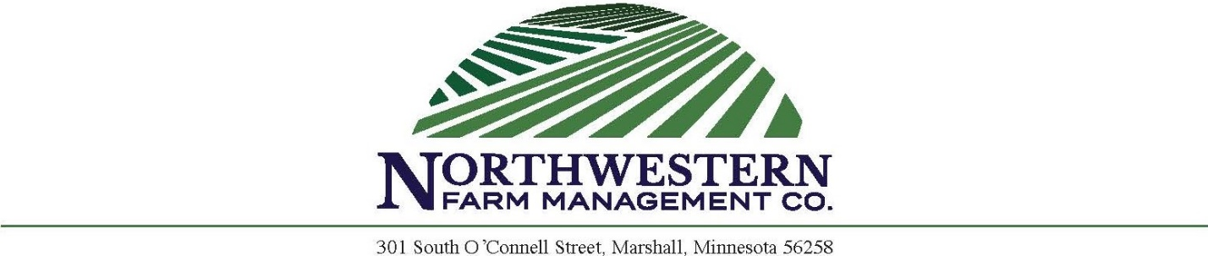

PETERSON PARTNERSHIP SEALED BID LAND AUCTION
(Redwood County, MN)
Parcel described as:
Part of SW ¼ and part of SW ¼ NW ¼ Section 19-112-39. (Underwood Twp) Redwood County, MN.

Times and Dates

Monday, November 14th, 2022
– Written bids and earnest money check must be received by Northwestern Farm Management Company by 5:00 PM.
Wednesday, November 16th, 2022
– All persons submitting bids will have opportunity to raise bids at EverSpring Inn & Suites, 1500 E. College Dr. Marshall, MN 56258 at 2:00 PM.

Farm Information: 132.15 deeded acres with approximately 130.18 tillable acres of which approximately 3 acres are enrolled in CRP buffer at a rate of $222/acre through 2032. Farm contains significate tile drainage, great farmability and a CPI of 84.8 with mostly Amiret loam and Canisteo clay loam soils. CRP contract will be split due to survey and sale.
Farm Location: Approximately 5 miles northwest of Milroy, MN
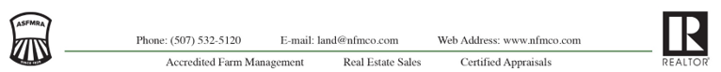

Sealed bid instructions:
- All potential buyers shall deliver or mail a sealed bid by 5 pm Monday, November 14th, 2022 to:

Northwestern Farm Management Company,
Attn: Corey Prins
301 South O’Connell St.
Marshall, MN 56258

- Minimum Bid is $1,057,200 or $8,000per acre on 132.15 acres.
- All bids must be accompanied by a $5,000.00 check for earnest money made out to Northwestern Farm Management Trust Account.
- The written bid shall state the total purchase price for the entire property.
- Only registered bidders may attend and participate in the auction.
- All persons submitting a written bid will be allowed to raise their bid after all bids have been opened.
- Bidders will be allowed to bid on other parcels the day of live auction.
- The property described above will be sold in “As Is and Where Is” condition.
- Seller will retain 100% of the 2022 cash rent payment and pay all the Real Estate Taxes due in 2022.
- Possession will be granted immediately after closing, subject to the 2022 lease terms.
- Buyer will be allowed to enter the property to preform fall tillage and fertilize upon the harvest of the 2022 crop.
- The successful bidder will enter into a purchase agreement and shall pay as earnest money 15% of the successful bid on the day of the auction.
- The entire balance of the purchase price will be due and payable on or before January 17, 2023, at which time marketable title shall be conveyed.
- Unsuccessful bidders will have checks returned to them at the conclusion of auction.
- The seller reserves the right to reject any and all bids and to waive any irregularities in the bidding.
- Property to be sold subject to any road, drainage, utility, or other easements of record.
- Announcements the day of the auction take precedent over written material.

BID SHEET FOR
PETERSON PARTNERSHIP LAND SALE
Parcel described as:
Part of SW ¼ and part of SW ¼ NW ¼ Section 19-112-39. (Underwood Twp) Redwood County, MN.
Submit bids in writing to:
Northwestern Farm Management Company
Attn: Corey Prins
301 South O’Connell Street
Marshall, MN 56258

All bids must be received by 5:00 pm November 14, 2022
Minimum bid is $1,057,200 or $8,000 per acre on 132.15 acres.
Bid must be accompanied by a $5,000 earnest money check.

Total Bid Amount $___________________________

Submit $5,000 earnest money check to Northwestern Farm Management Company Trust Account.
All persons submitting bids will have opportunity to raise bids at the EverSpring Inn & Suites, 1500 E College Drive, Marshall, MN 56258 on November 16th at 2:00 PM. Successful bidder will sign purchase agreement at the conclusion of the auction and make earnest money payment of 15% of final purchase price less $5,000 earnest money check. Sale is not contingent on buyer financing. Bidders must be prequalified. Unsuccessful bidders will have $5,000 checks returned to them at conclusion of auction. Seller reserves the right to refuse any and all offers.

NAME: _______________________ LENDER’S NAME: _______________________
ADDRESS: ______________________ ADDRESS: ____________________________ _______________________ ____________________________
PHONE: _______________________ PHONE: ____________________________
Email: _______________________ Email: ____________________________

