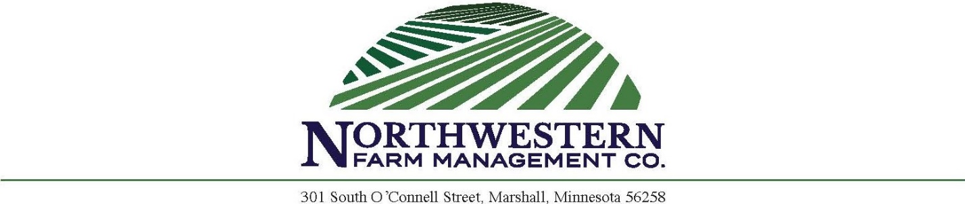

PETERSON PARTNERSHIP SEALED BID LAND AUCTION
(Redwood County, MN)
Parcel described as:
E½ NW¼ Section 29-113-37 (Kintire Twp) Redwood County, MN.

Times and Dates

Monday, November 14th, 2022
– Written bids and earnest money check must be received by Northwestern Farm Management Company by 5:00 PM.
Wednesday, November 16th, 2022
– All persons submitting bids will have opportunity to raise bids at Belview Community Center, 202 South Main St, Belview, MN 56214 on November 16th at 10:00 AM

Farm Information: 80± acres, 76.42 FSA tillable acres, CPI 89.6. A great opportunity to purchase 80 acres of Redwood County farmland. This is a beautiful, gently rolling tract. The farm has significant tile drainage and produces well. Perfect farmability and accessed directly off a blacktop highway.
Farm Location: Approximately 2 miles south of Belview, MN
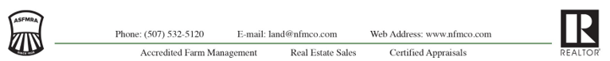

Sealed bid instructions:
- All potential buyers shall deliver or mail a sealed bid by 5 pm Monday, November 14th, 2022 to:

Northwestern Farm Management Company,
Attn: Corey Prins
301 South O’Connell St.
Marshall, MN 56258

- Minimum Bid is $640,000 or $8,000 per acre on 80 acres.
- All bids must be accompanied by a $5,000.00 check for earnest money made out to Northwestern Farm Management Trust Account.
- The written bid shall state the total purchase price for the entire property.
- Only registered bidders may attend and participate in the auction.
- All persons submitting a written bid will be allowed to raise their bid after all bids have been opened.
- Bidders will be allowed to bid on other parcels the day of live auction.
- The property described above will be sold in “As Is and Where Is” condition.
- Seller will retain 100% of the 2022 cash rent payment and pay all the Real Estate Taxes due in 2022.
- Possession will be granted immediately after closing, subject to the 2022 lease terms.
- Buyer will be allowed to enter the property to preform fall tillage and fertilize upon the harvest of the 2022 crop.
- The successful bidder will enter into a purchase agreement and shall pay as earnest money 15% of the successful bid on the day of the auction.
- The entire balance of the purchase price will be due and payable on or before January 17, 2023, at which time marketable title shall be conveyed.
- Unsuccessful bidders will have checks returned to them at the conclusion of auction.
- The seller reserves the right to reject any and all bids and to waive any irregularities in the bidding.
- Property to be sold subject to any road, drainage, utility, or other easements of record.
- Announcements the day of the auction take precedent over written material.

BID SHEET FOR
PETERSON PARTNERSHIP LAND SALE
Parcel described as:
E½ NW¼ Section 29-113-37 (Kintire Twp) Redwood County, MN.
Submit bids in writing to:
Northwestern Farm Management Company
Attn: Corey Prins
301 South O’Connell Street
Marshall, MN 56258

All bids must be received by 5:00 pm November 14, 2022
Minimum bid is $640,000 or $8,000 per acre on 80 acres.
Bid must be accompanied by a $5,000 earnest money check.

Total Bid Amount $___________________________

Submit $5,000 earnest money check to Northwestern Farm Management Company Trust Account.
All persons submitting bids will have opportunity to raise bids at the Belview Community Center, 202 South Main St, Belview, MN 56214 on November 16th at 10:00 AM. Successful bidder will sign purchase agreement at the conclusion of the auction and make earnest money payment of 15% of final purchase price less $5,000 earnest money check. Sale is not contingent on buyer financing. Bidders must be prequalified. Unsuccessful bidders will have $5,000 checks returned to them at conclusion of auction. Seller reserves the right to refuse any and all offers.

NAME: _______________________ LENDER’S NAME: _______________________
ADDRESS: ______________________ ADDRESS: ____________________________ _______________________ ____________________________
PHONE: _______________________ PHONE: ____________________________
Email: _______________________ Email: ____________________________

